The Myth of Easy Time Signature Checking
Donald Byrd |  | Geoff Chirgwin
School of Informatics & Jacobs School of Music  Indiana University  donbyrd@indiana.edu |  | School of Informatics  Indiana University  chirgwin@indiana.edu

ABSTRACT
It is widely considered that computer checking for agreement between time signatures and actual duration of measures is a simple and reasonably reliable way of detecting problems in encoded Western music notation. This is not true. It can certainly be useful, but in general, simple methods are not nearly as reliable as it would seem, even in music by mainstream composers published by highly respectable publishers. The basic issue is that, in a significant number of cases, both understanding rhythm from notation and inferring meter from notation are much harder than people tend to assume. That means that all automated procedures related to meter and rhythm—beaming, inferring the duration ratios of tuplets, subtleties of performance—are likely to be unreliable in many cases.

This paper considers the complex relationship between time signatures and the rhythmic contents of measures. In theory, a time signature clearly and explicitly indicates the exact duration of a measure's rhythmic content. But determining the durational sum of the measure’s contents is often far less clear and less explicit. Ambiguous time signatures and deliberate violations of time signature/content agreement, both of which are not uncommon in some genres of music, make matters more difficult. We give examples of all of these problems.

- INTRODUCTION
It is widely considered that computer checking for agreement between time signatures and actual duration of measures is a simple and reasonably reliable way of detecting problems in encoded Western music notation. We have heard this attitude expressed by many people, music-informatics researchers as well as ordinary musicians. Indeed, it is implemented in one form or another by many programs. For example, such well-known programs as Finale ??DO WHAT? GIVE WHAT EXAMPLES? And a well-known OMR (Optical Music Recognition) program discards notes at the end of a measure once the duration indicated by the time signature has been reached, presumably because it thinks the “extra” notes don’t belong. Unfortunately, we have seen it misinterpret a series of notes as each having longer durations than they actually have, then make things worse by discarding the last few notes of the measure! (In fairness, we must point out that this was around 2007; we do not know if the current version of the program has the same weakness.) But even without misinterpreted note durations, depending on ??NEED A FEW WORDS checking is problematic.

In conventional Western music notation, a time signature both defines the duration of the measure and describes its metric structure, i.e., the pattern of strong and weak beats it contains. In simple meters like 3/4, the top-level division of the beat is into two parts; compound meters like 6/8 divide the beat into three parts. We are less concerned with the rhythmic qualities of the time signature (whether it is even or odd; its divisions, such as triple, or quadruple; or whether it is simple or compound), and more concerned with the duration indicated by the time signature agreeing with durational sum of the rhythmic contents of the measure. In the latter lies the ambiguity and presents the greatest difficulty. It may seem that this is a matter of simply summing the rhythmic durations of a measure, but a universal solution is far more complicated than that.

A few examples should point up the complexity of the problem. Some music repeatedly changes from subdividing the measure in one beat pattern to another: a well-known example is “America” from Bernstein’s West Side Story, which alternates between simple triple (3/4) and compound duple (6/8). “America” is actually notated in 6/8, but such music sometimes exhibits both time signatures literally side by side ??SHOW AN EXAMPLE. Since the measure duration of both time signatures is the same, this leads to no problems for duration checking. But the third movement of Brahms’ Trio, Op. 101, repeatedly changes measure duration: it carries the time signature “3/4 2/4”, meaning each measure is in either 2/4 or 3/4, and here the ambiguity is a problem. Finally, consider a passage from J.S. Bach’s Goldberg Variations, no. 26, that changes time signature in the middle of a measure (Figure 9): at the beginning of the excerpt, the lower staff is in 3/4, the upper in 18/16. This “obviously” makes no sense, since ¾ = .75 does not equal 18/16 = 1.125! But the change occurs on a beat, and it goes from a simple triple (3/4) to a compound triple meter (18/16), while the other change in the excerpt does the opposite. The only reasonable interpretation is that—with each meter change—a simultaneous tempo change preserves the (real-time) durations of beats, and what is happening is simply a change from duple to triple subdivision of the beat. Indeed, the passage is invariably performed that way. This means that the passage could have been written entirely in 3/4, with 6:4 sextuplets in the 18/16 sections; it is not obvious why it is not written that way.

- TYPES AND EXAMPLES
Here are some specific problem cases, with a example or three of each; more examples of many of the situations are listed in “Extremes of Conventional Music Notation” (Byrd 2010a), “Music Notation Counterexamples” (a very early version appears in Byrd 1984), and shown and discussed in the “Gallery of Interesting Music Notation” (Byrd 2010b). Within each category, cases appear roughly in decreasing order of frequency. Note, however, that the frequency is heavily dependent on the style, genre, etc.

1. The time signature and actual duration may truly disagree.
* Anacruses or “pickup” bars at the beginning of a movement, and compensating incomplete bars at the end of the movement. Common in the music of numerous 18th- and early 19th-century composers, including many of the most famous, and especially in minuets and scherzi. 8 of the 18 movements of Mozart’s first six piano sonatas have this feature; so do 9 of the first 12 Bach chorales (in the Kalmus/Belwin-Mills collection of 389 chorales). Examples: the minuets of Mozart’s Piano Sonata K. 282 and Beethoven’s Piano Sonatas Op. 2 nos. 1 and 2; the first movement of Mozart’s Piano Sonata K. 283; the scherzo of Beethoven’s Symphony no. 4; etc. An unusual use is to break the measure and system at the pickup, rather than at the barline: Figure 1 is as a tune appears in a published collection of folksongs (??REF).

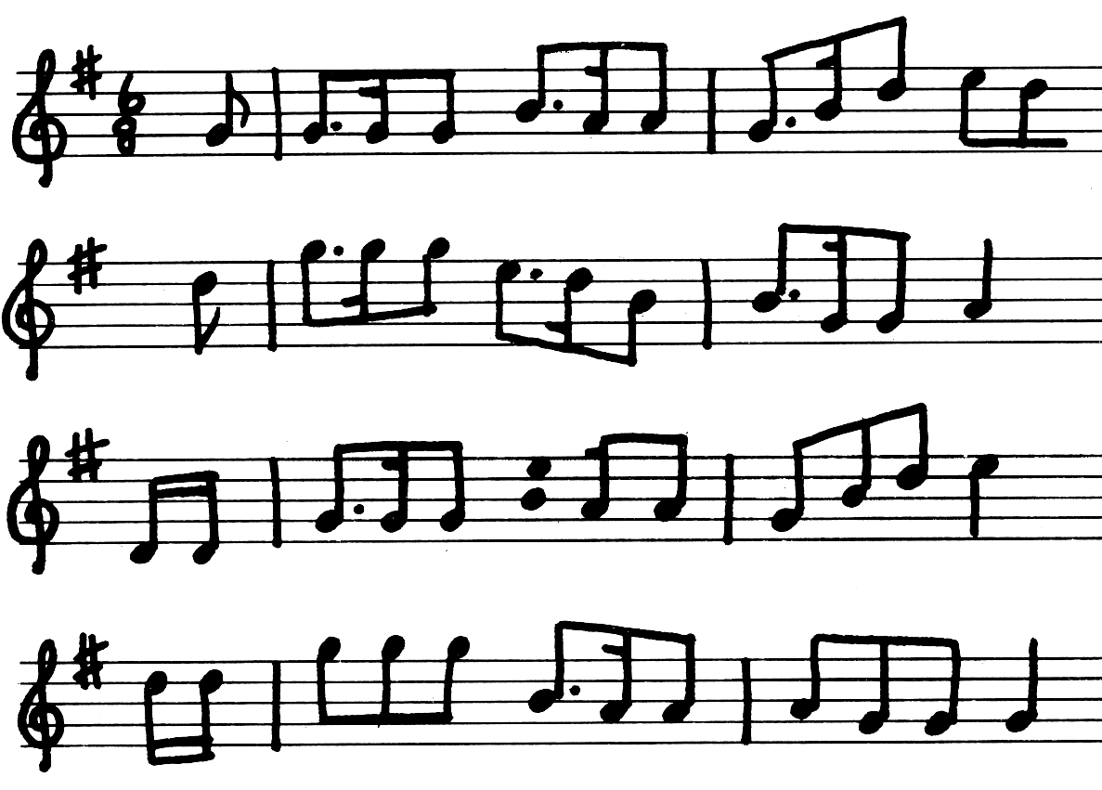
Figure 1. Bonny Wee Lassie, traditional

* Metrically-free passages, e.g., as in cadenzas and cadenza-like sections (often written in small notes, but often not) and cadenzas. Fairly common. Examples, all written entirely in normal-size notes: the piano solos in m. 2, m. 4, and m. 6 of Beethoven’s Emperor Concerto, I; much of the last page of Chopin’s Ballade no. 1, Op. 23; the opening four systems of Ysaye’s Ballade Sonata for solo violin, Op. 27 no. 3.

Figure 2. Beethoven’s Emperor Concerto, I

* Other. Relatively rare. One example is in Van Eyck’s Der Fluyten Lusthof, (New Vellekoop ed.), vol. 1, pp.1, 10, 17, 24, 28, 58: each page includes a brief piece marked “C”, but barlines (single or, usually, double) appear only at the ends of phrases, every six or eight 4/4 measures. P. 59 has a longer piece that starts the same way but then changes to “proper” barlines, Also, a clearcut example of an unmarked change of time signature is the end of Schumann's Carnaval, no. 6 (Florestan): the piece is marked 3/4, and it unmistakably is until the last four measures, when there are suddenly only four eighth notes per measure, i.e., 2/4. (This may simply be an editor’s mistake, but we suspect not: it appears this way in both the Breitkopf/Clara Schumann ed. and an unidentified edition on the Web, http://imslp.org/wiki/File:Schumann_-_Carnaval,_Op_9.pdf .)

2. The time signature and actual duration may appear to disagree to a computer program, though a (presumably human) expert would see there's no such problem.
* Unmarked tuplets. Very common, especially for triplets, and especially when many appear consecutively. In fact, tuplet and non-tuplet groups occasionally intermix in such a way that it's difficult for anyone to tell what the actual rhythm is; Stone's book on 20th century notation (Stone 1980) cites a case, in Bartók’s String Quartet no. 5.
* Tuplets with duration-changing factors that are not easily computed by a program, since not all the information needed is explicit. Common: this is the case for a large percentage of tuplets other than triplets , i.e., the denominator is not given explicitly and/or they're not the conventional ratio. For example, a tuplet with numerator “5” and no denominator might involve a factor of 5:4, 5:3, or even 5:6.

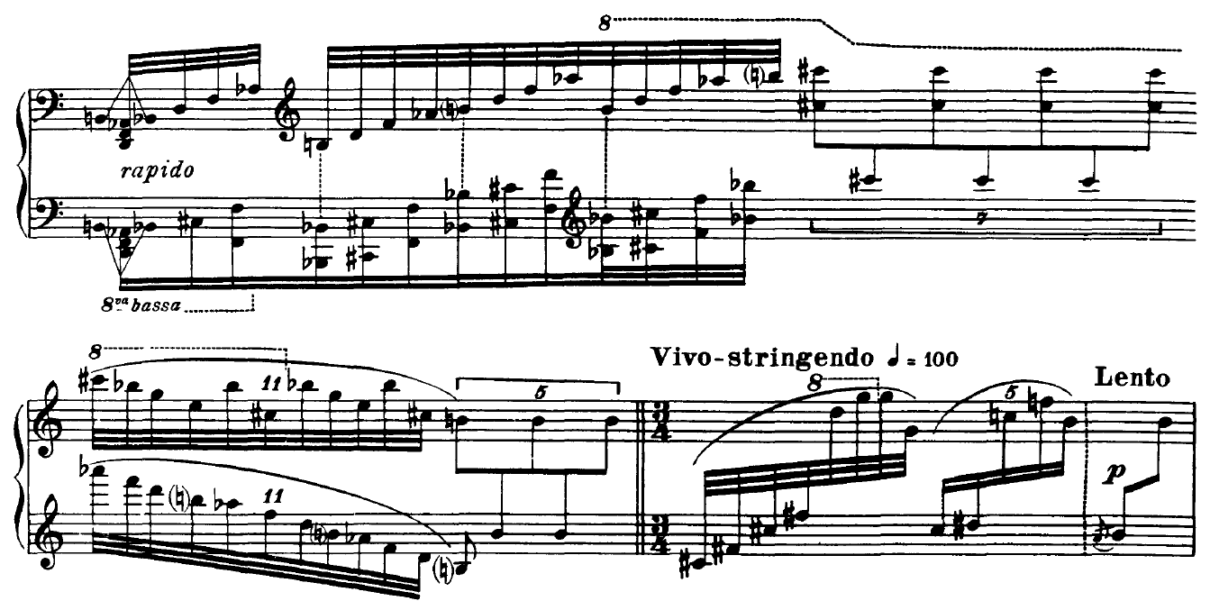
Figure 3. Stravinsky’s Petrouchka

* Interaction between voices that appear and/or disappear within a measure. This is fairly common in idiomatic piano music (e.g., Chopin), and in highly-linear keyboard music when a voice crosses staves. Appearances/disappearances can occur at any metric position, not necessarily even at beat boundaries. Extreme example: A voice (indicated by upstems on isolated notes) appears, disappears, and reappears five times in Chopin’s Ballade No. 4 in f, Op. 52.
Figure 4. Chopin’s Ballade no. 4 in f, Op. 52.

* The “impossible rhythm” situation described by Jay Hook (2008) where two voices share noteheads but the overall rhythms disagree such that the note starts at different times in the two voices. Not common, but not rare in idiomatic piano music. Usually the note in one voice is part of a tuplet and the other is a “normal” note. Hook lists over 50 examples, the vast majority by well-known 19th-century composers. Every instance I know of is in idiomatic piano music, e.g., by Chopin (Nocturne, Op. 15 no. 2, shown and discussed in Byrd 2010b), Brahms, Ravel, and Schumann.

Figure 5. Chopin’s Nocturne, Op. 15 no. 2

* Mid-measure repeat bars and double “barlines” separating sections that really aren’t barlines. Common. These cases usually involve pickup bars and compensating incomplete measures. 7 of the 8 movements of Mozart’s first six piano sonatas that have pickup measures also have mid-measure repeat bars. Examples: the dividing line between the minuet or scherzo and the trio of numerous symphonies, sonatas, etc. of the 19th-century, e.g., the minuets of Mozart’s Piano Sonata K. 282 and Beethoven’s Piano Sonatas Op. 2 nos. 1 and 2; the first movement of Mozart’s Piano Sonata K. 283; the scherzo of Beethoven’s Symphony no. 4; Bach Chorales nos. 6 and 7. In some cases, a time signature change occurs at the same point, i.e., in the middle of the measure! See below for an example of this.

Figure 6. Mozart’s Piano Sonata K. 283

* Notes whose actual duration clearly disagrees with the usual interpretation. Fairly common. For example, in Baroque music, it’s not too unusual for a dotted eighth note to be followed in the same quarter-note duration by three 32nds instead of two, even when the 32nds are definitely not a triplet, so that the dotted eighth actually lasts for five 32nds instead of the expected six (i.e., 3 16ths). An odd case is in Brahms’ Capriccio for piano, Op. 76 no. 1, where a dotted half note clearly lasts only eleven 16ths (shown in Byrd 2010b).

Figure 7. Brahms’ Capriccio for piano, Op. 76 no.1

* Alignment suggesting notes are consecutive that are really simultaneous. By this, we mean something more than the common situation of a chord with notes on both sides of the stem. Unusual. An extreme example: in Scarbo of Ravel's Gaspard de la Nuit, in a measure with notes on the downbeat on the same staff with a clef change in between (discussed in Byrd 2010b).

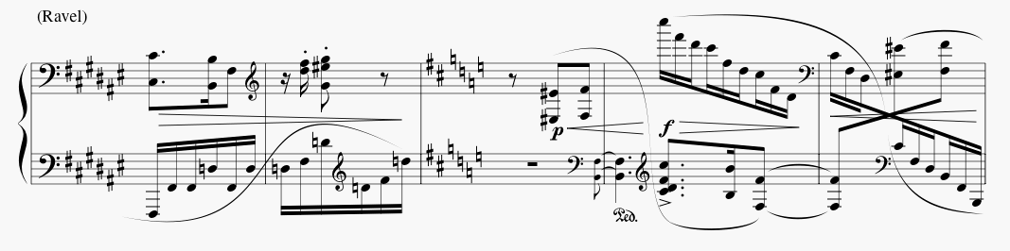
Figure 8. Scarbo from Ravel’s Gaspard de la Nuit

* The time signature is ambiguous. Unusual. Examples: in Brahms' Piano Trio, Op. 101, III, “3/4 2/4”, meaning each measure is in either 2/4 or 3/4; later, “9/8 6/8”, similarly meaning each measure is either 9/8 or 6/8. Several instances occur in Ysaye’s Solo Violin Sonatas, Op. 27.
* Glissandi with not all notes shown. Unusual. Example: numerous places in Stravinsky’s Le Sacre du Printemps; Kodaly’s Hary Janos Suite, I, m.3, piano; probably harp parts in many works.
* The time signature changes in the middle of the measure. Rare. Examples: Bach: Goldberg Variations, no. 26 (discussed in Byrd 2010b); the last movements of each of the Beethoven Pianos Sonatas Opp. 109, 110, 111. In the 3rd movement of Schumann’s Symphony no. 1, this happens at the repeat bar between scherzo and trio.
Figure 9. Bach’s Goldberg Variations, no. 26
3. There is no time signature, so checking is impossible. Some music in Western notation has no barlines and therefore no time signature. Examples: the cadenza in the first movement of the Tchaikovsky Violin Concerto; much Satie (e.g., the Gnoissienes), some Ives (e.g., several long passages in the Concord Sonata), transcriptions of early music, etc. This really also applies to some cadenzas, though for them, there's nearly always normally-barred music with a time signature preceding; see discussion of cadenzas above. Or the music may not have a time signature even though it has barlines, perhaps because the meter changes repeatedly. For example, seven of the 300-odd hymns in Worship in Song (1996) have no time signature for the reason just given; the same is true of Hindemith’s Sonata for Solo Viola, Op.25 No.1, IV.

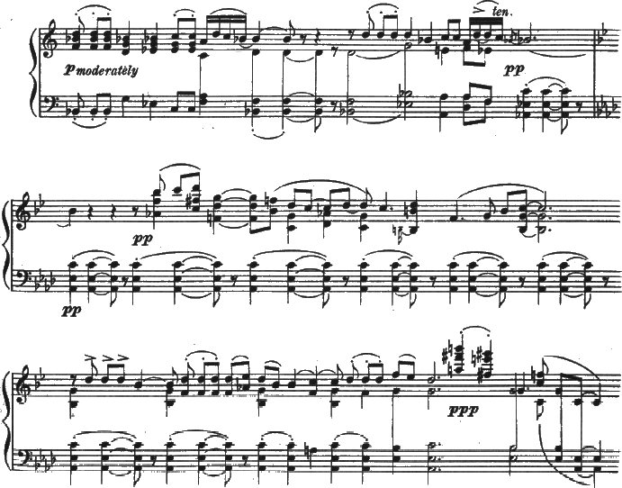
Figure 10. Ives’ Concord Sonata

Figure 11. The Hymn of the Resurrection

Figure 12. Ya Viene El Alba, Spanish-American folk song

- CLOSING
There is a dichotomy between human and machine interpretation of any image as complex as a page of music notation. Paralleling this dichotomy is the difference between graphic and symbolic representations. Because of the rigidity of symbolic representations, information is often lost when moving from a graphic representation to a symbolic one. This can result in normalization of the original notation into a form where the ambiguity is artificially clarified, and similar normalization sometimes occurs at the hands of a human editor. For example, the earliest instance we know of a tie into “thin air” occurs in a piano piece by Schumann ??NEED REF!, but the Clara Schumann edition re-notates the passage with a conventional tie.

The heart of this problem is the perpetual challenge of capturing the composer’s (or arranger’s or performer’s) intent in the most concise and meaningful way possible. As a result, we believe that any automated procedure related to meter and rhythm, including time signature checking, will always be difficult in a significant number of cases.

- REFERENCES
- Byrd, Donald (1984). Music Notation by Computer (doctoral dissertation, Computer Science Dept., Indiana University). Ann Arbor, Michigan: UMI ProQuest (order no. 8506091). Available at: http://www.informatics.indiana.edu/donbyrd/DonDissPageImages.pdf .

- Byrd, Donald (2010a). Extremes of Conventional Music Notation. Available at: http://www.informatics.indiana.edu/donbyrd/CMNExtremes.htm .

- Byrd, Donald (2010b). Gallery of Interesting Music Notation. Available at:
http://www.informatics.indiana.edu/donbyrd/InterestingMusicNotation.html .

- Hook, Julian (2008). How to Perform Impossible Rhythms. Talk at Society for Music Theory conference, Nashville, Tennesee, November 2008.

- Stone, Kurt (1980). Music Notation in the Twentieth Century: A Practical Guidebook. New York: W. W. Norton.

- Worship in Song: A Friends Hymnal (1996). Philadelphia: Friends General Conference.

- Matins of the Resurrection: also known as Paschal Matins (2009). Metropolitan Cantor Institute Pittsburgh, Pennsylvania

